Univariate Analysis – Central Tendency Measures
We are provided with a placement dataset, and the objective is to calculate the Central Tendency Measures for the same.
The measures of central tendency used in this analysis are:
- Mean
- Median
- Mode
Dataset Overview:
- Total number of rows: 215
- Total number of columns: 15
- Quantitative columns: 7
- Qualitative columns: 7
Since Central Tendency Measures can be calculated only for numerical data, the analysis is performed on the quantitative columns listed below:
- sl_no – Count/identifier of the candidates
- ssc_p – 10th standard percentage
- hsc_p – 12th standard percentage
- degree_p – Degree percentage
- etest_p – Entrance test percentage
- mba_p – MBA percentage
- salary – Salary offered to the candidates
The Mean, Median, and Mode values for these columns were calculated using Python built-in functions. This analysis helps in understanding the overall distribution, average performance, and common patterns within the placement dataset.

Please find the table below,

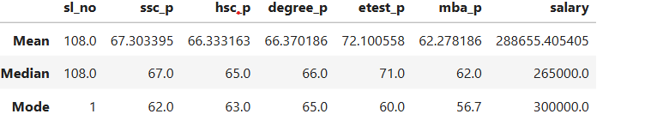
Mean Analysis of Placement Data
A total of 215 students took part in the placement process. Based on the data collected, the students showed a consistent academic performance throughout their studies.
On average, the students scored 67.30% in SSLC and 66.33% in HSC. The average Entrance Exam score was slightly higher at 72.10%. In higher education, the students obtained an average of 63.37% in their degree and 62.28% in MBA.
The average annual salary offered to the students during placements was approximately ₹2.89 lakhs per annum.
Overall, the analysis shows that the students who participated in the placement process had moderate academic performance and were able to secure reasonably good placement opportunities with average salary packages.

Median Analysis of Placement Data


A total of 215 students took part in the placement process. Based on the data collected, the students showed a consistent academic performance throughout their studies.
We have calculated median for the same placement data,
the students scored 67% in SSLC and 65% in HSC. The median of Entrance Exam score was slightly higher at 71%. In higher education, the students obtained an average of 66% in their degree and 62% in MBA.

The median annual salary offered to the students during placements was approximately ₹2.65 lakhs per annum.

From above mean and median data, there was a difference of 22 thousand and we can come to conclusion that there might some outlier present in the above data.

Mode Analysis of Placement Data



Mode Analysis of Placement Data
A total of 215 students participated in the placement process. Based on the data collected, the students showed consistent academic performance throughout their studies.
We have calculated the Mode for the placement dataset to identify the most frequently occurring values in the data.
The most scored percentage among students was 62% in SSLC and 63% in HSC. The mode of the Entrance Exam score was 60%. In higher education, the most frequently occurring score was 65% in Degree and 56.7% in MBA.
The most offered annual salary during placements was approximately ₹3.00 lakhs per annum.
From the above Mode analysis, it can be observed that most students scored around 62% and above in their academic performance. Interestingly, the Entrance Exam and MBA scores are comparatively lower than the Mean and Median values. However, the salary distribution appears to be slightly higher when compared with the Mean and Median salary analysis, indicating that a larger number of students received salary packages around ₹3 lakhs per annum.

